**II. WHY AGILE**

Introduction

Lesson Introduction

Welcome to the lesson on why Agile has taken the market by storm in today's digital age.

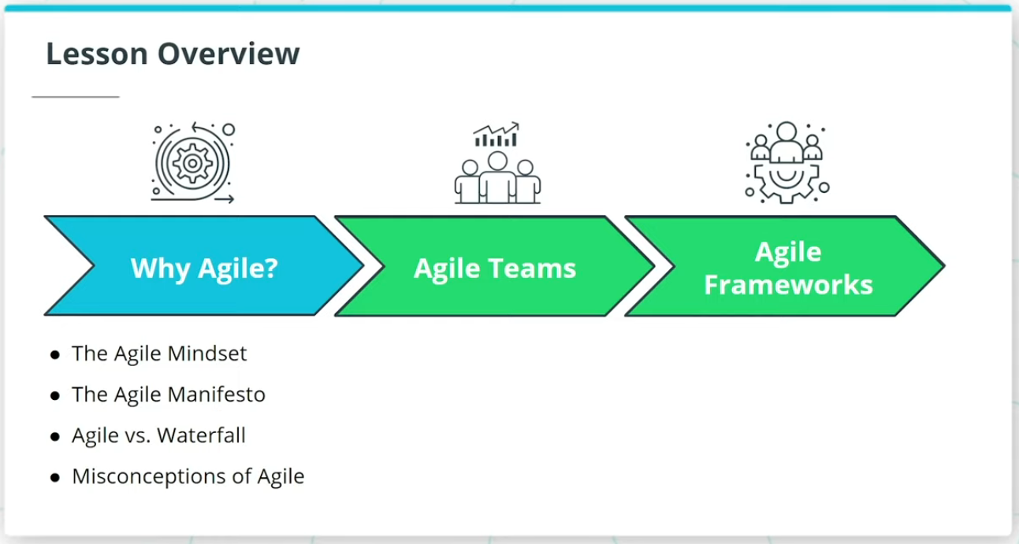

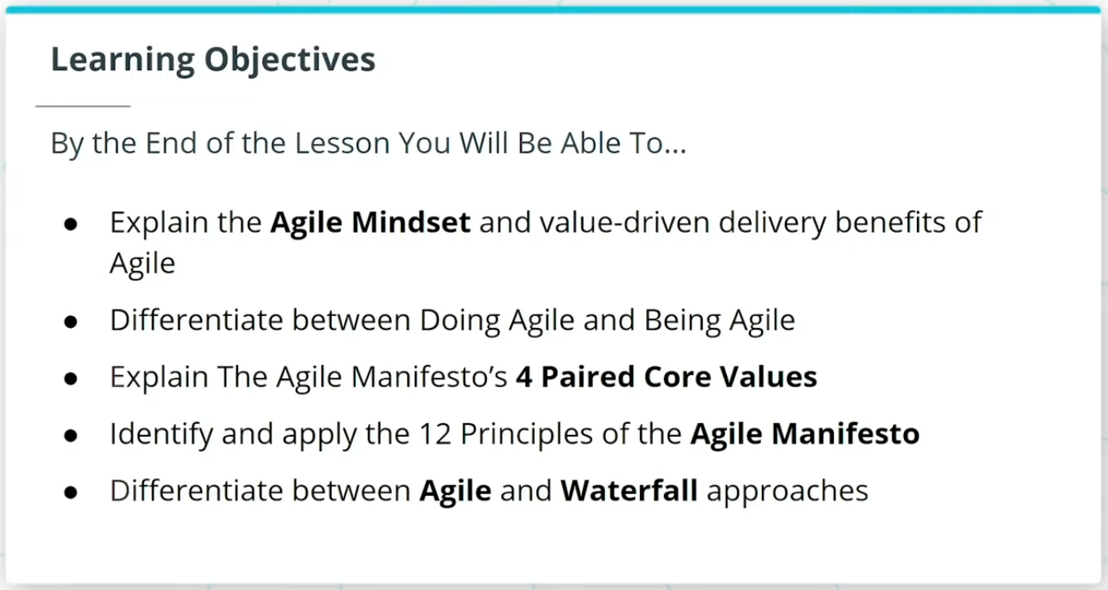

### **What We Will Cover In This Lesson**

In this lesson, we will focus on the foundational theory behind Agile. We will discuss:

* The Agile Mindset and how it sets the tone for ‘Being’ Agile versus just ‘Doing’ Agile
* The Agile Manifesto, and how it is seen as the foundational set of 4 Paired Core Values and 12 Principles that sets the foundation for all Agile Frameworks
* How Agile differs from the more traditional Waterfall approach to product development

We will wrap up the lesson with an important discussion on common misconceptions about Agile.

### **By the End of the Lesson, You Will Be Able To...**

* Explain the Agile Mindset and value-driven delivery benefits of Agile
* Differentiate between Doing Agile and Being Agile
* Explain The Agile Manifesto’s 4 Paired Core Values
* Identify and apply the 12 Principles of the Agile Manifesto
* Differentiate between Agile and Waterfall approaches

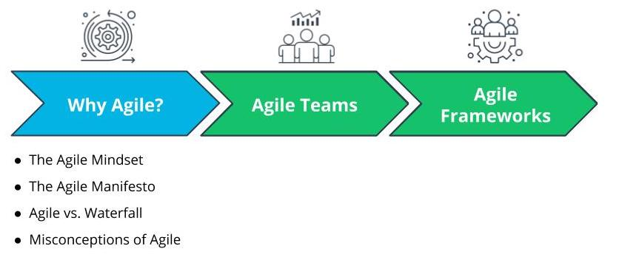

What We Will Cover In This Lesson

# Why Agile

## Why Are Organizations Adopting Agile Part 1

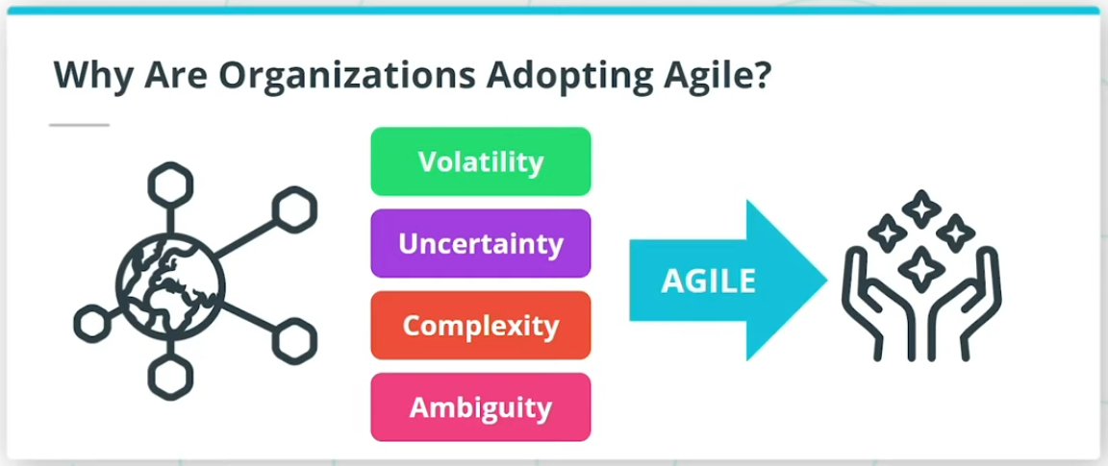

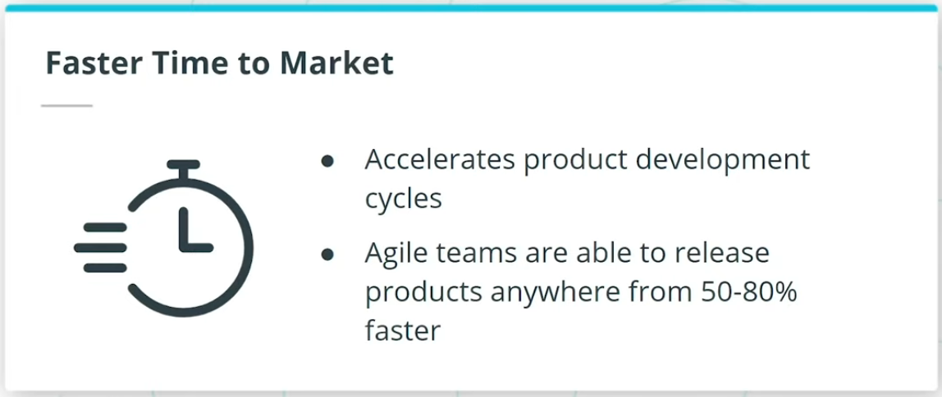

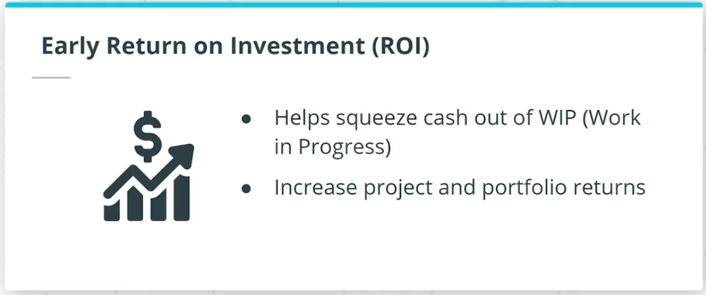

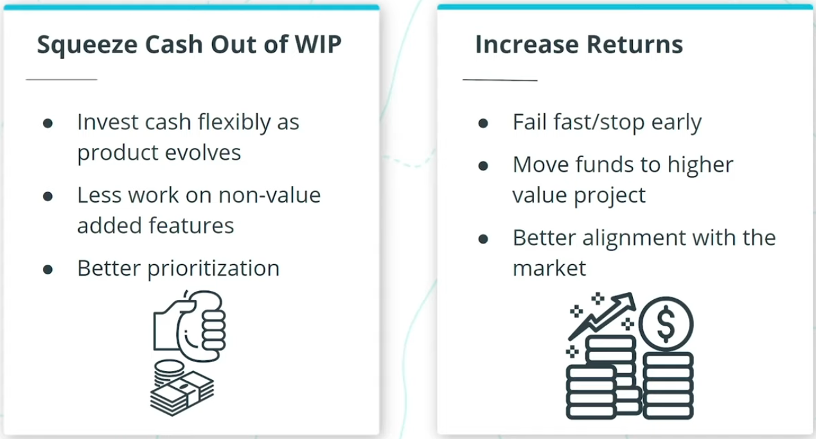

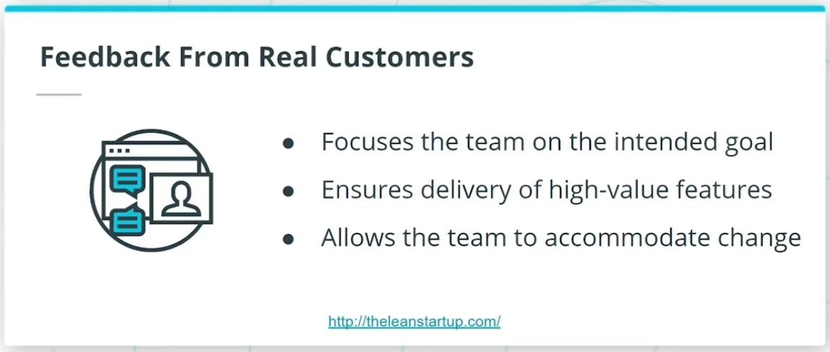

So, why are forward-thinking organizations rapidly adopting Agile? And why are we seeing that global professional bodies such as The Project Management Institute (PMI) in their PMBOK Guide and The International Institute of Business Analysis (IIBA)’s BABOK Guide, have incorporated and highlighted the importance of Agile in project management, business analysis, and other product delivery activities?

In an increasingly interconnected and competitive global marketplace, I am seeing Agile being leveraged by successful organizations across the globe to thrive in today’s digital age. Agile enables organizations to predictably deliver value in a world where we are constantly being challenged with Volatility, Uncertainty, Complexity, and Ambiguity. Organizations that I have seen go through Agile transformation have benefited from the following:

* Faster time to market
* Early ROI
* Feedback from Real Customers

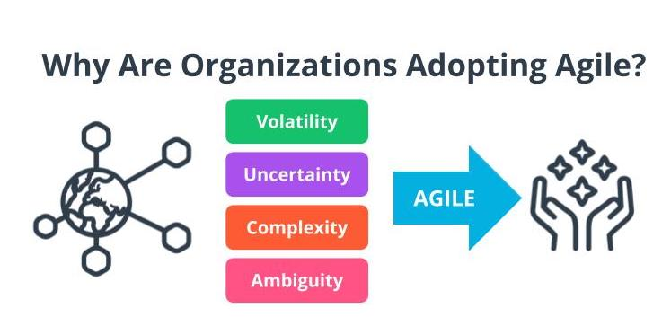

Volatility, Uncertainty, Complexity, Ambiguity

*Note: You are going to learn more about VUCA later in this lesson.*

Why Are Organizations Adopting Agile Part 2

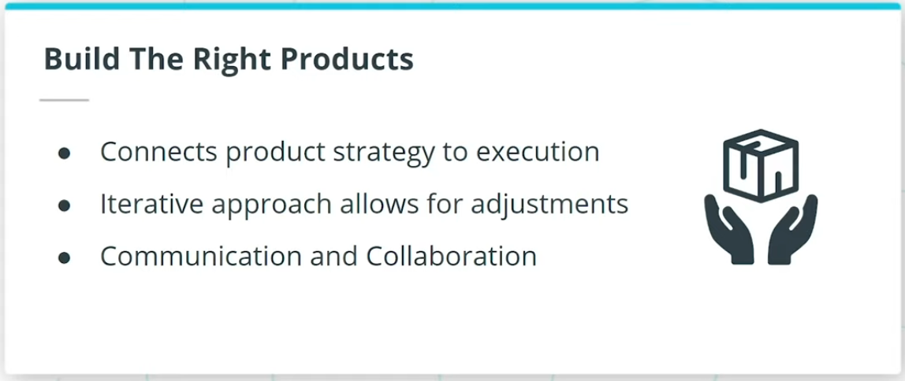

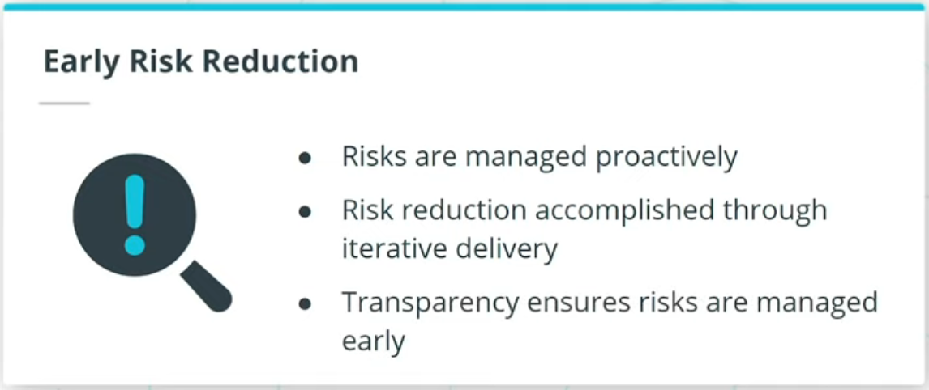

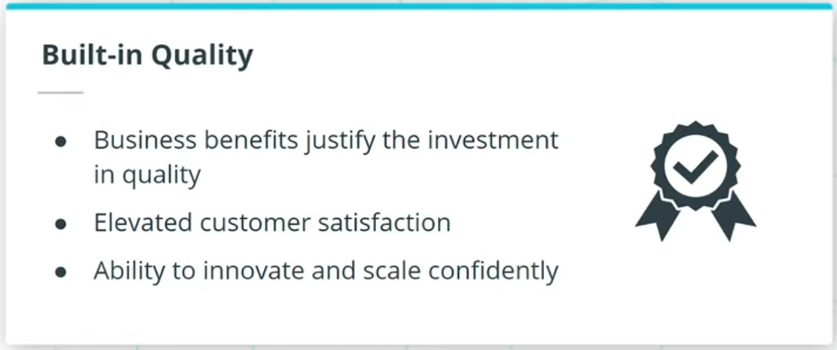

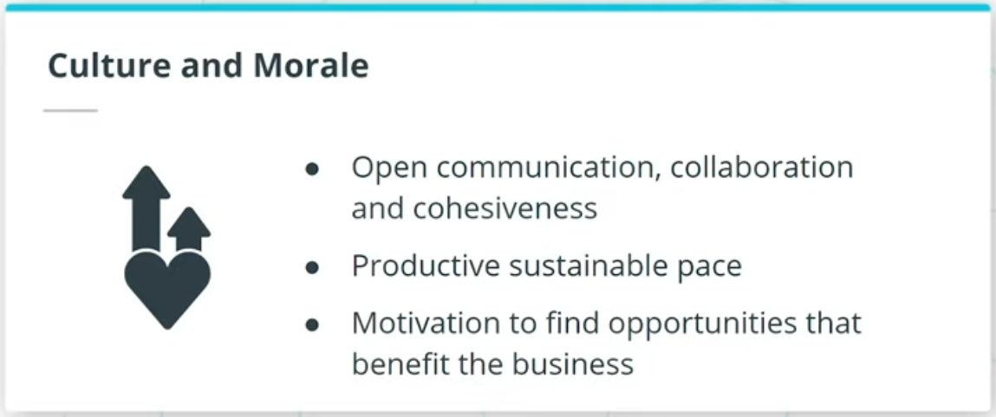

### **Organizations that go through Agile transformation have also benefited from:**

* Build the right products
* Early risk reduction
* Built-in quality
* Culture and morale

## Efficiency vs. Effectiveness

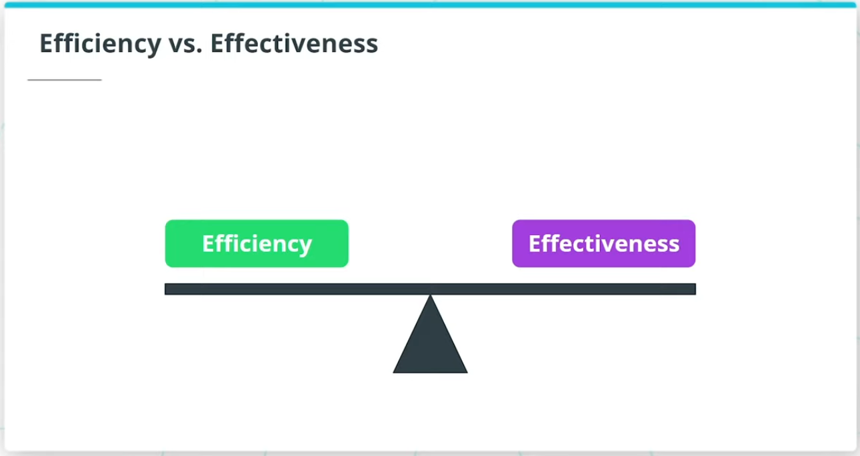

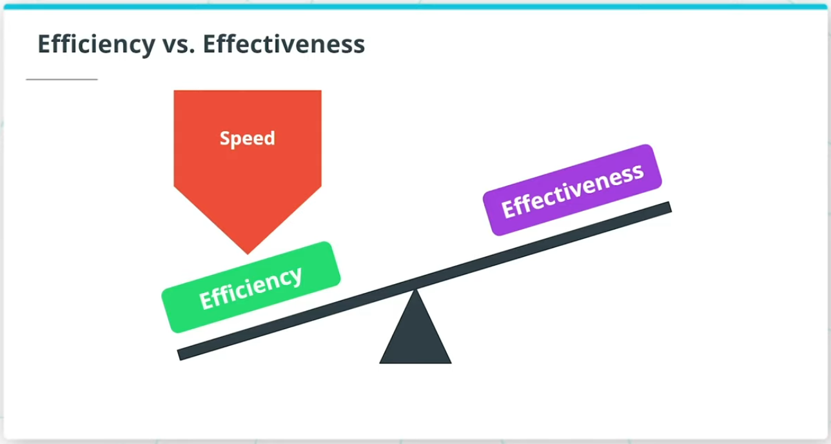

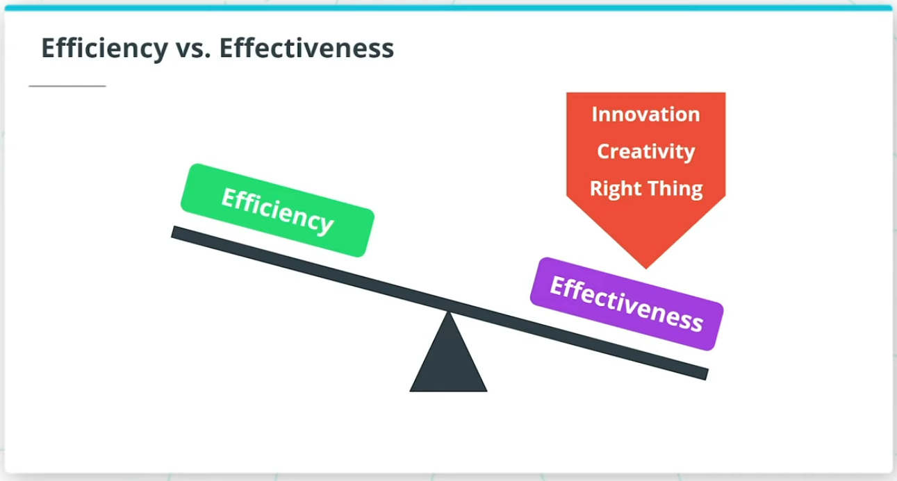

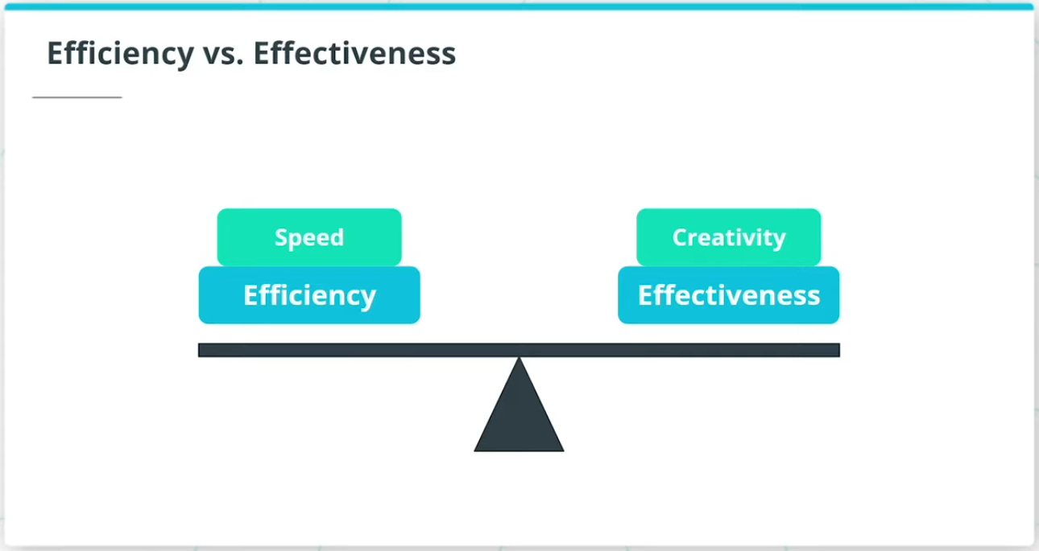

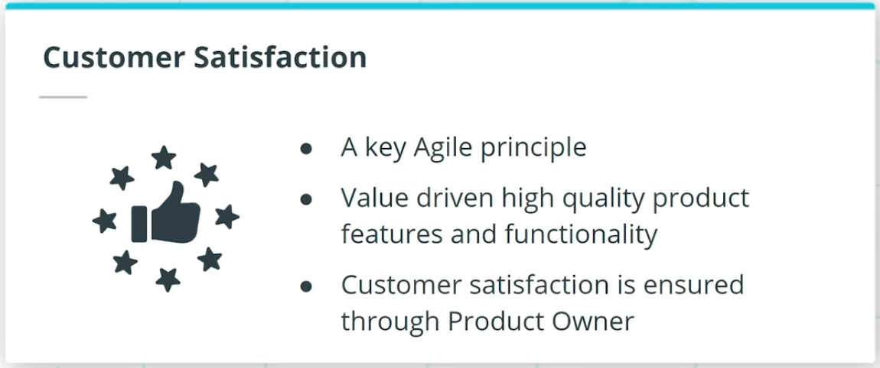

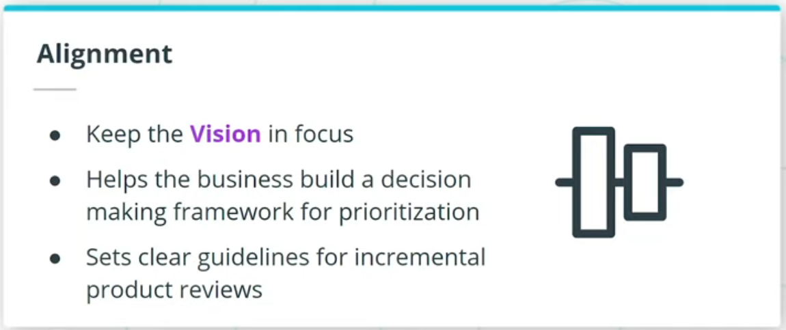

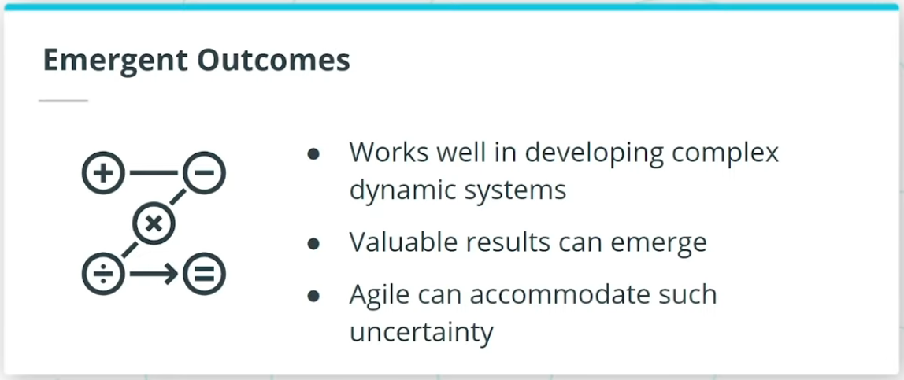

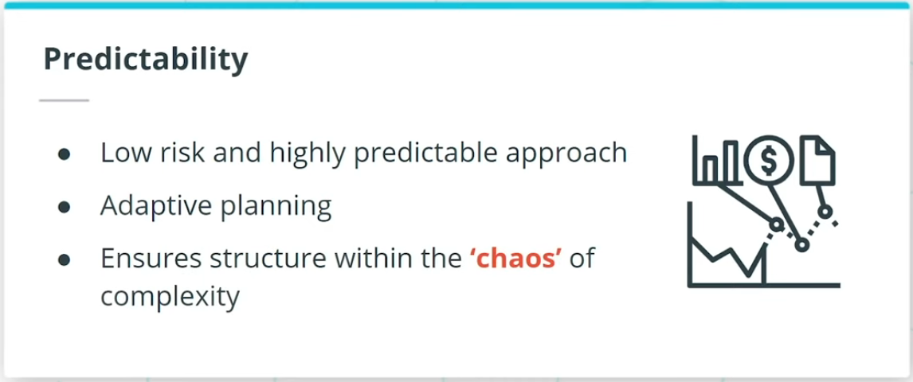

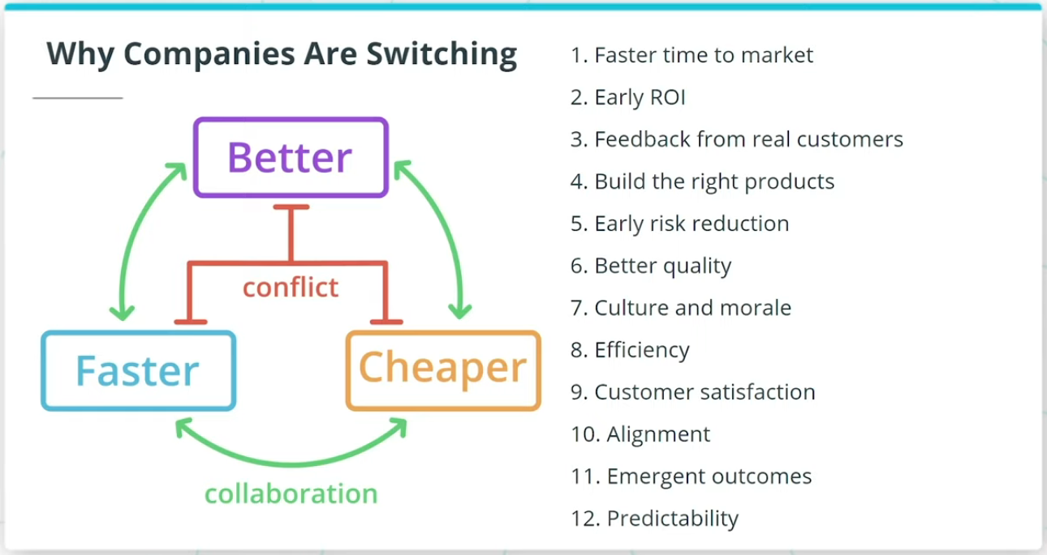

### **Efficiency and effectiveness is a fine balancing act that Agile recommends.**

If you’re only focused on going fast, you prioritize efficiency.

If you’re trying to focus on innovation, creativity, and making sure you’re working on the right thing, you need to focus on effectiveness.

This is often done at the cost of efficiency.

Agile ensures a balanced approach whereby Agile Teams ensure there is a balance between speed and creativity.

Agile transformations also benefit from:

* Customer Satisfaction
* Alignment
* Emergent Outcomes
* Predictability

Organizations want to use Agile to get there by developing products better, faster, and cheaper.

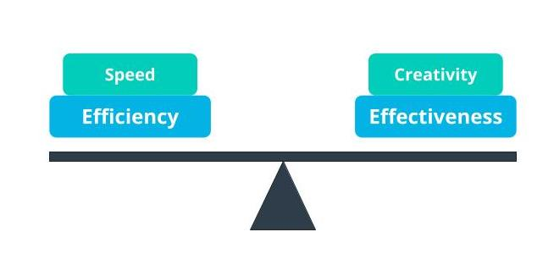

Agile Balances Efficiency And Effectiveness

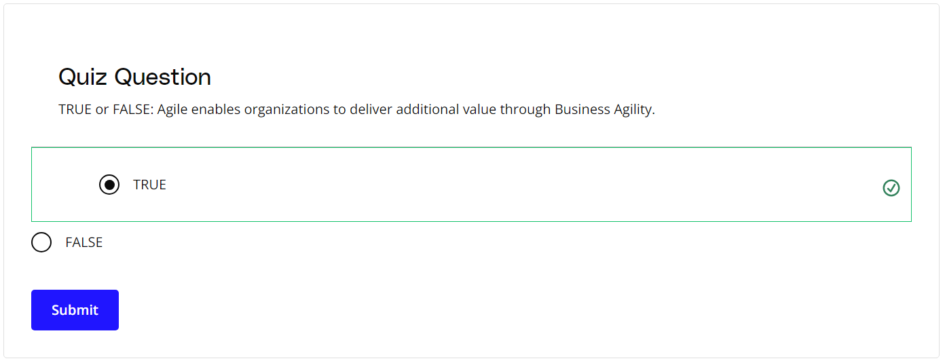

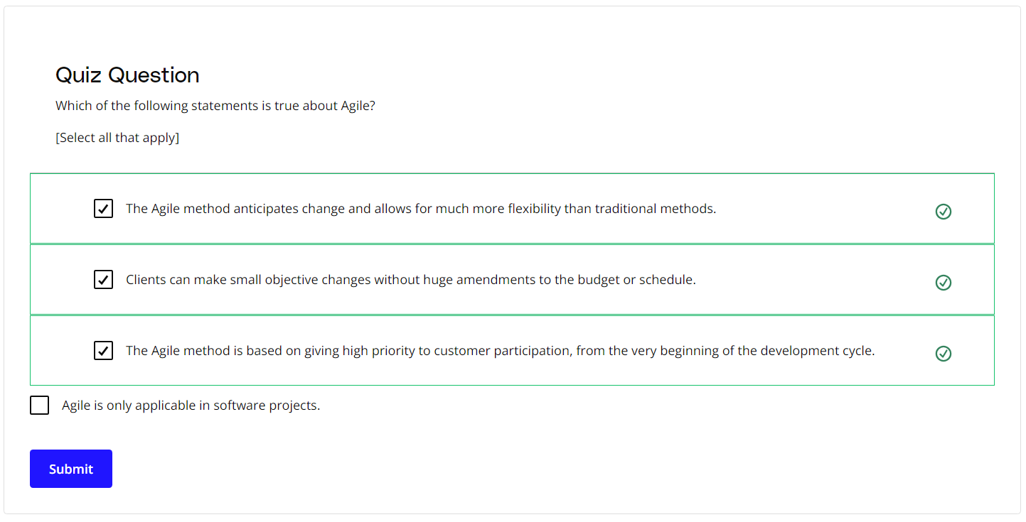

### **New Terms**

* **Ambiguity**: Ambiguity refers to a lack of clarity, such as not having a clear understanding of the genuine needs of the customer and end-users
* **Complexity**: Complexity exists when there are many interconnected parts and variables that influence each other
* **Muda**: Lean principles refer to the Japanese term Muda as waste; Agile teams focus on the removal of non-value adding tasks that are seen as Muda
* **Product Owner**: A business proxy or representative of the business users who is the Voice of the Customer (VOC)
* **Return on Investment (ROI)**: Return on investment (ROI) is calculated as the ratio between net profit and cost of investment over a defined period of time
* **Uncertainty**: The extent to which an organization can confidently predict or forecast the future; more uncertainty makes it harder to predict
* **Voice of the Customer**: A term used to articulate the steps to capture customer's needs
* **Volatility**: Volatility is when there are unexpected or unstable possibilities that may influence the work being done
* **VUCA**: Volatility, Uncertainty, Complexity, Ambiguity
* **WIP (Work in Progress)**: The work that has been started but not yet completed

### **Additional Resources**

* [**The Lean Startup**](http://theleanstartup.com/) by Eric Ries

# How Experts Approach Agile

## Thinking About Agile

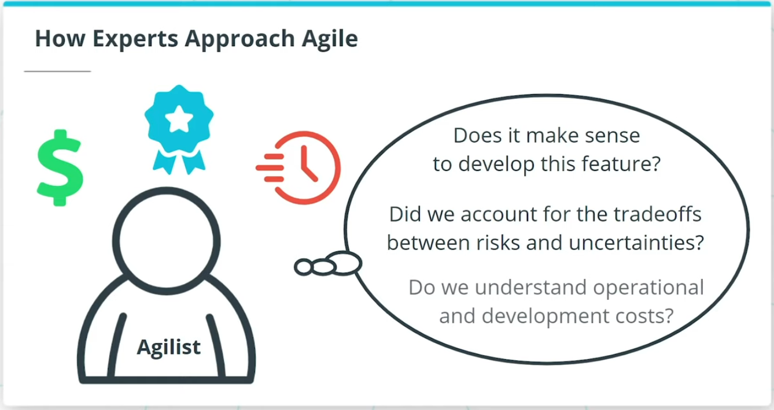

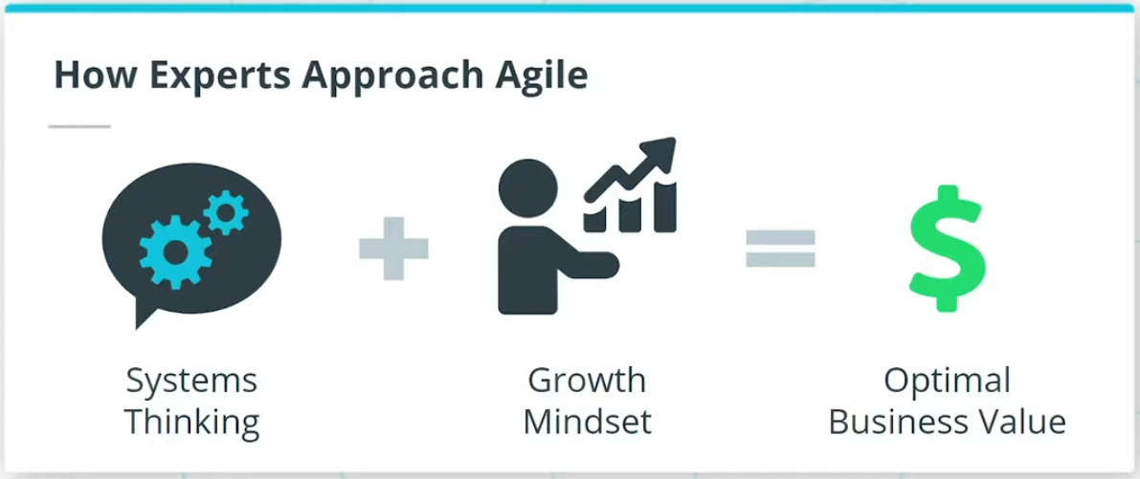

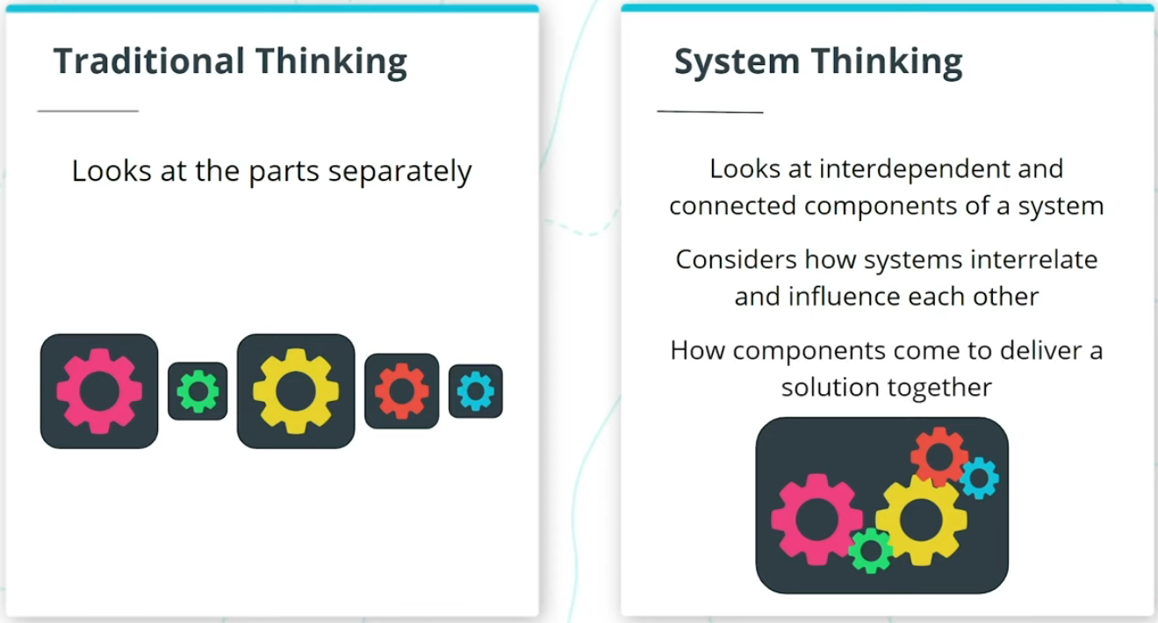

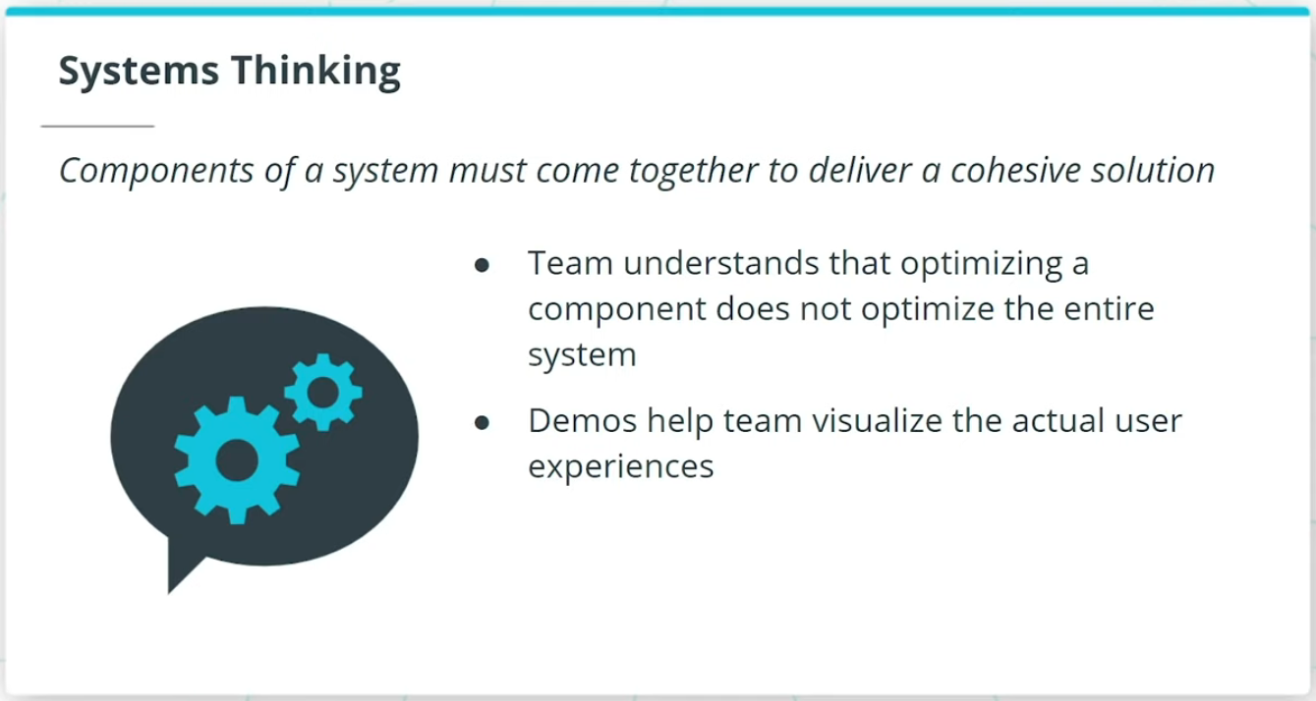

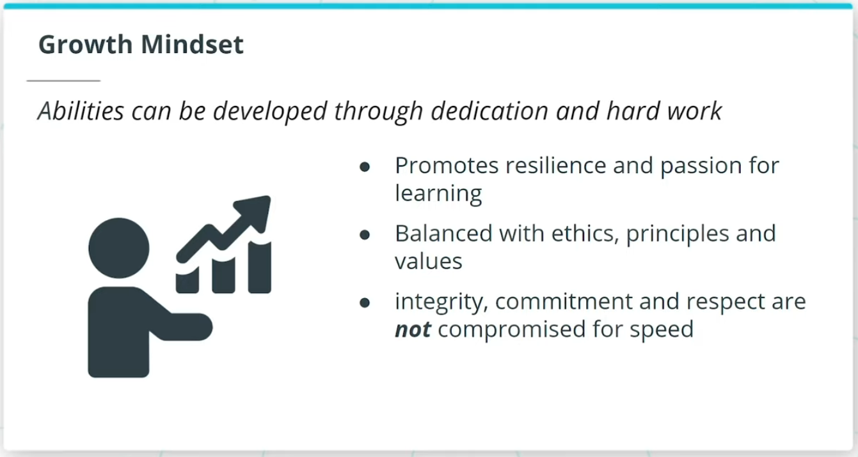

### **Agile Is Based on a Systems Thinking Approach and a Growth Mindset**

* Agilists adopt a practical and realistic approach to delivering the best value, and quality, in the shortest sustainable time.
* A Systems Thinking approach, reinforced by a Growth Mindset, helps Agile experts deliver optimal business value.
* Systems thinking takes a holistic approach in which the Agile Team looks at the way a system's components interrelate and influence each other and how these components come together within the context of larger systems to deliver a solution.
* In a growth mindset, individuals on a team have the mindset that their abilities can grow through dedication and hard work.

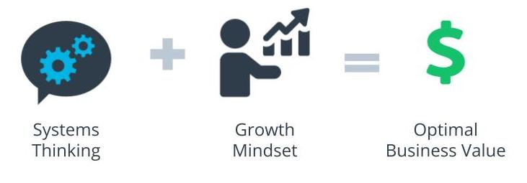

Systems Thinking + Growth Mindset = Optimal Business Value

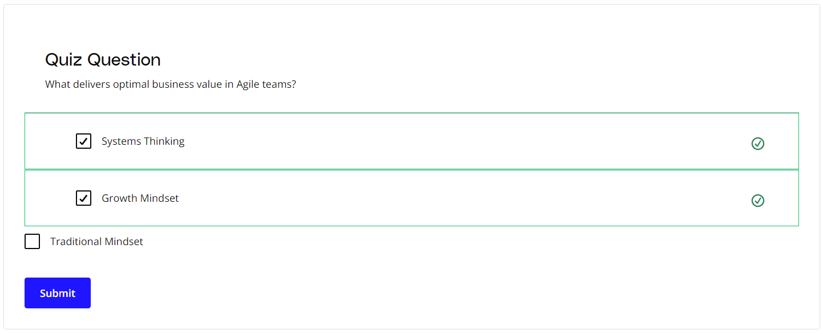

### **New Terms**

* **Growth Mindset**: The mindset that an individual's abilities can grow through dedication and hard work
* **Systems Thinking**: A holistic approach that looks at the way a system's components interrelate and influence each other and how these components come together within the context of larger systems to deliver a solution

### **Additional Resources**

* Brad Smith and Carol Ann Browne. ***Tools and Weapons: The Promise and the Peril of the Digital Age***. Penguin, 2019.  
  In this book, Brad Smith and Carol Ann Browne share how one of the world's largest and most powerful companies leverages Agile practices to overcome today's challenges in the global marketplace.

# The Agile Mindset

## What Is the Agile Mindset?

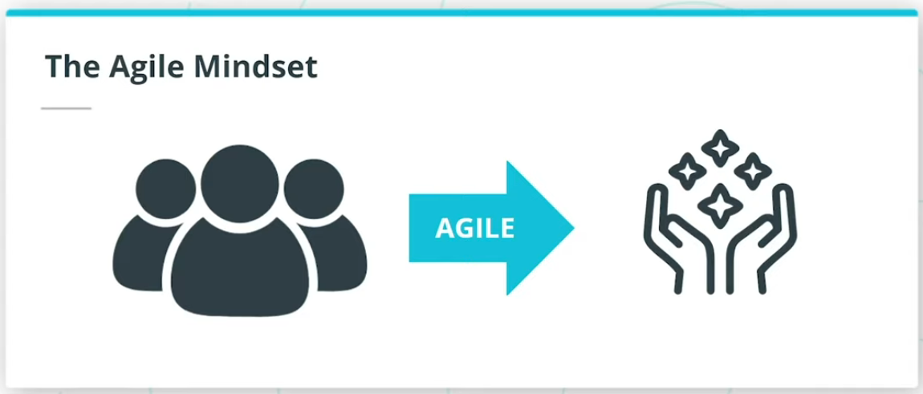

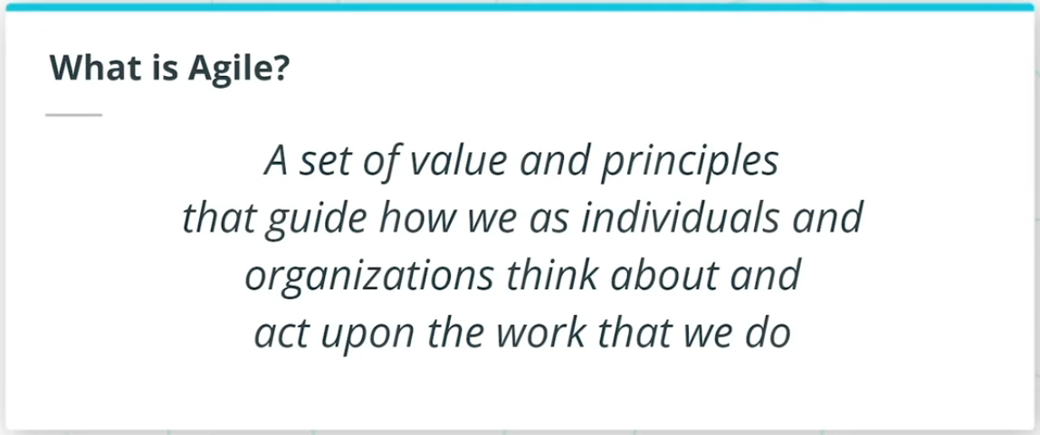

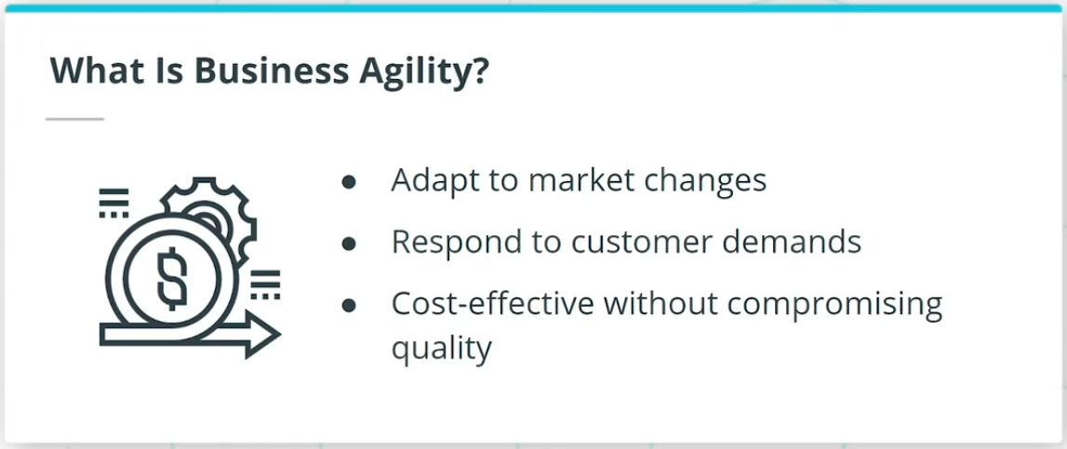

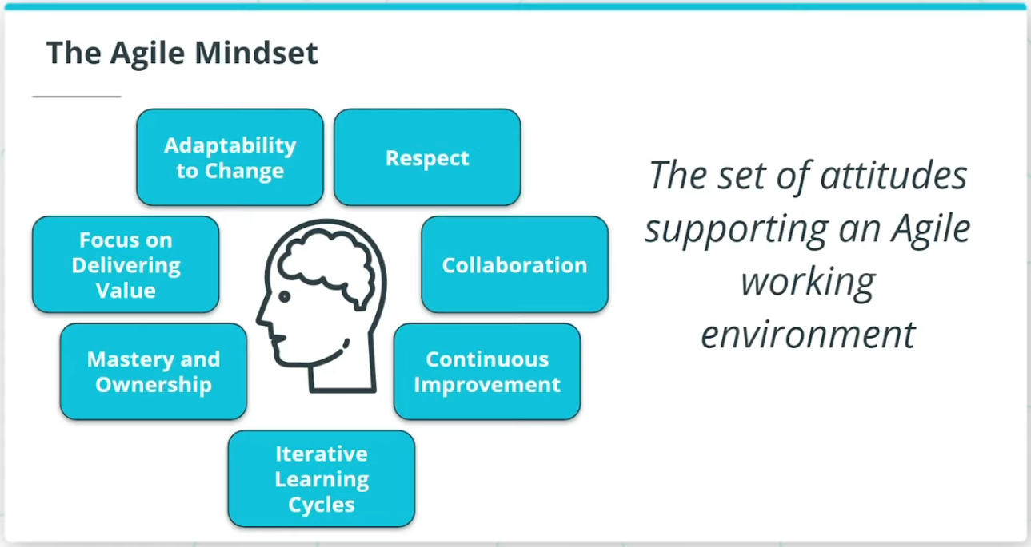

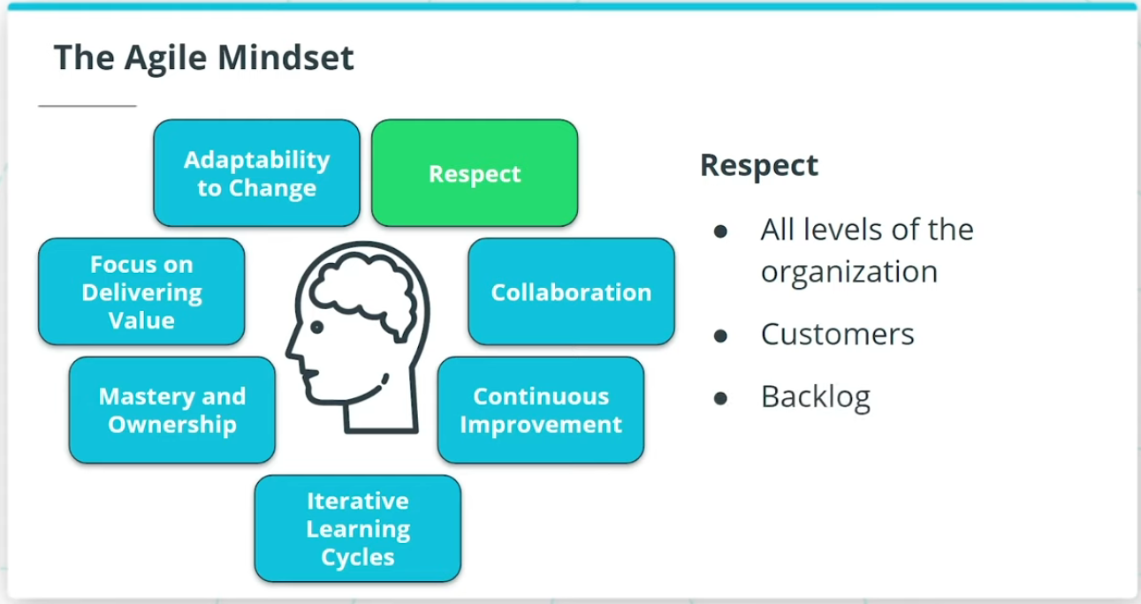

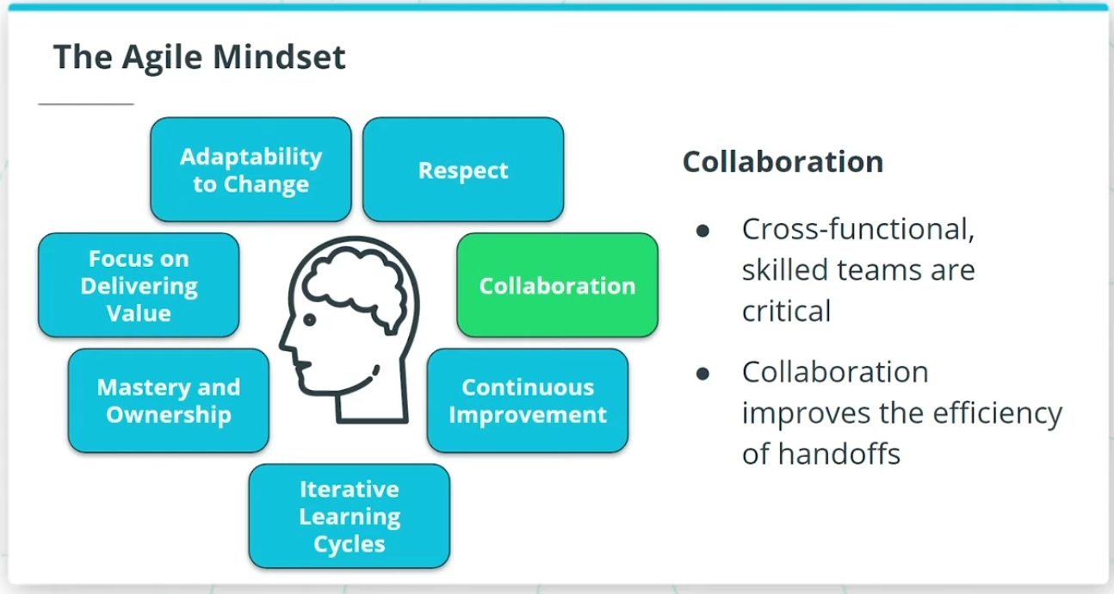

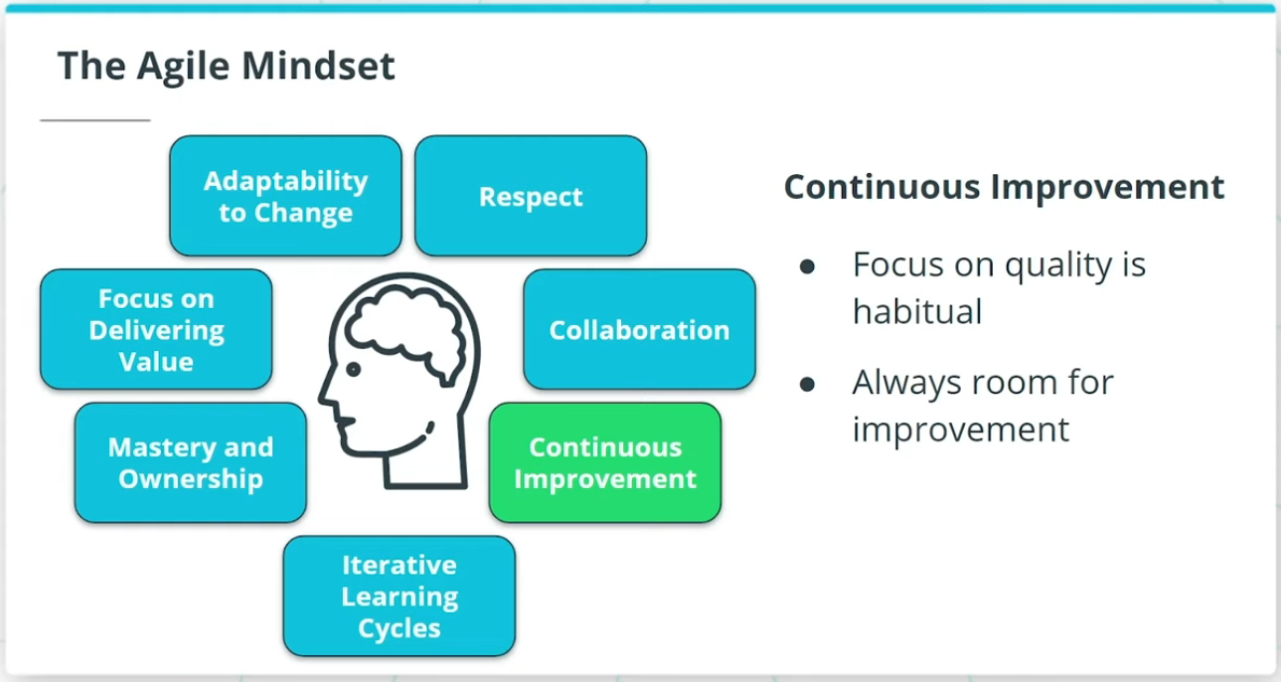

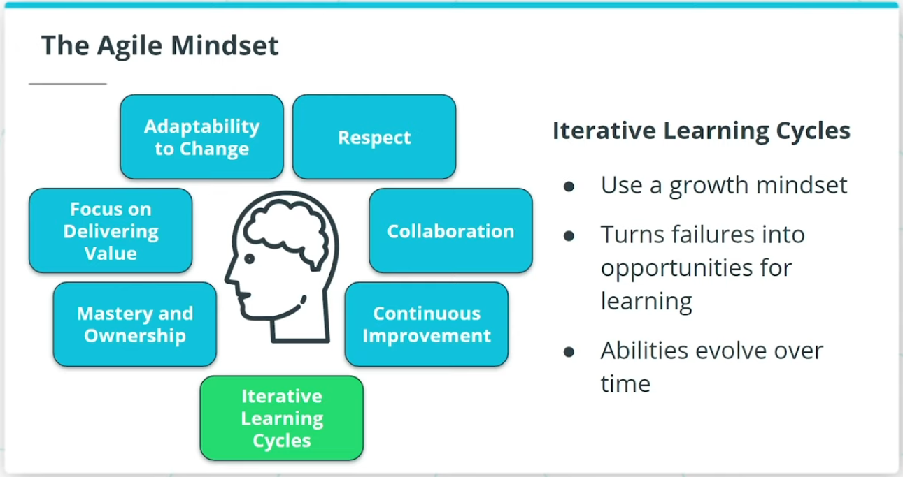

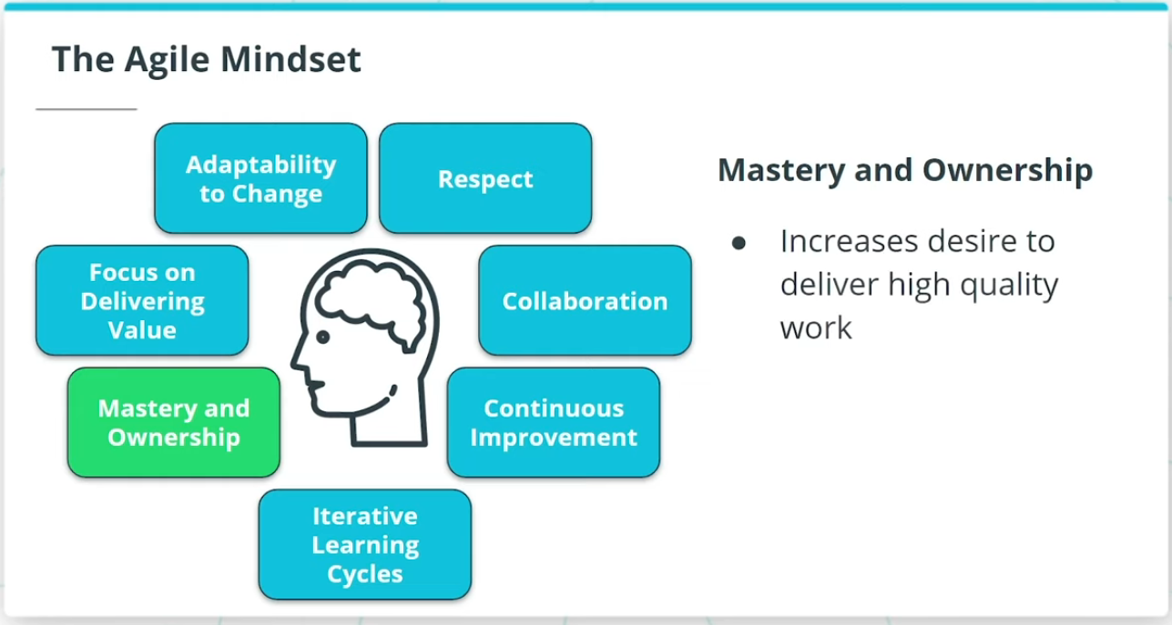

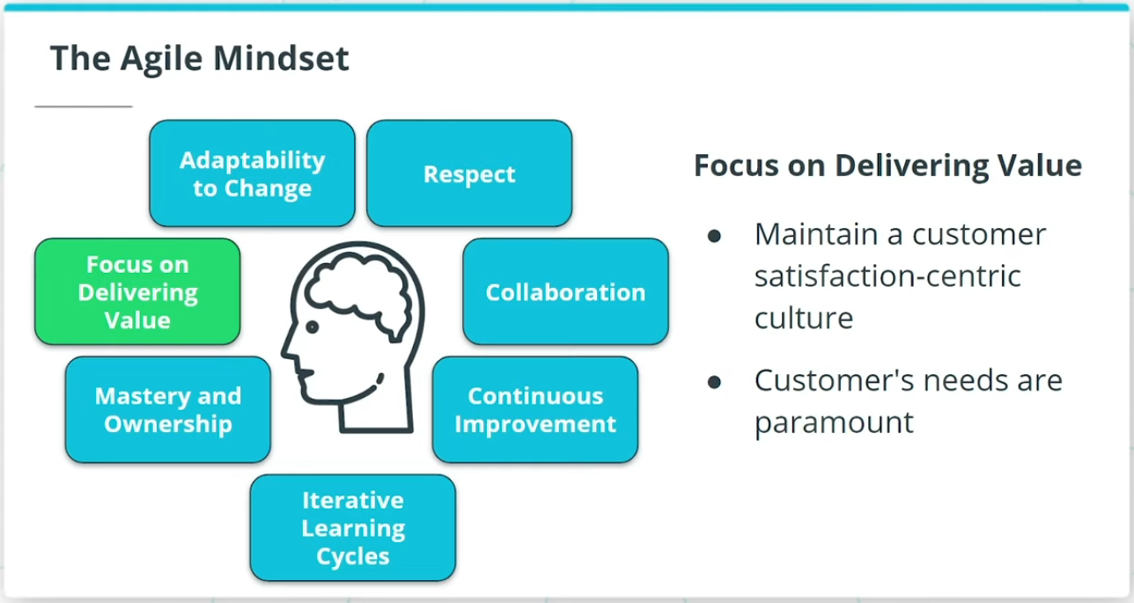

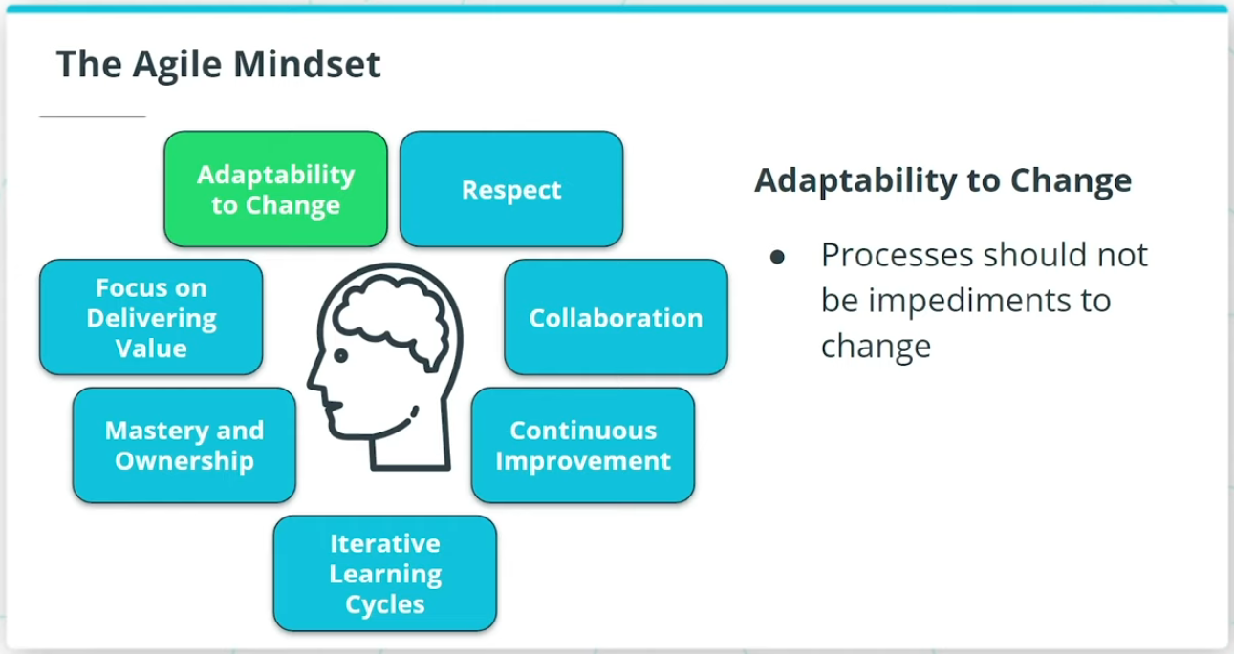

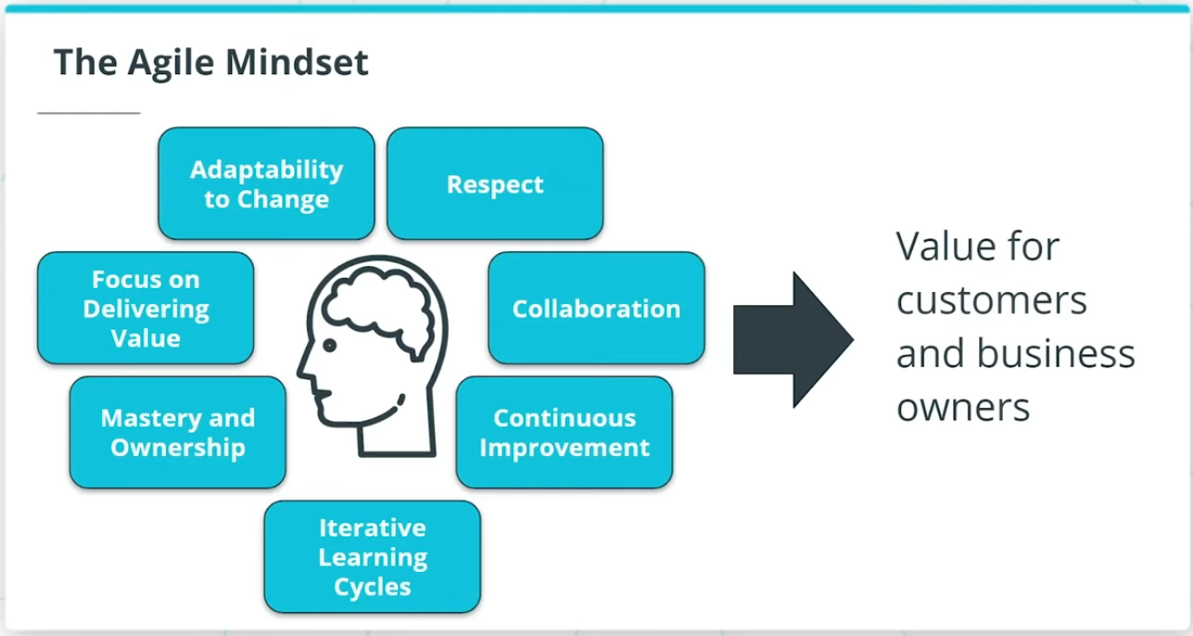

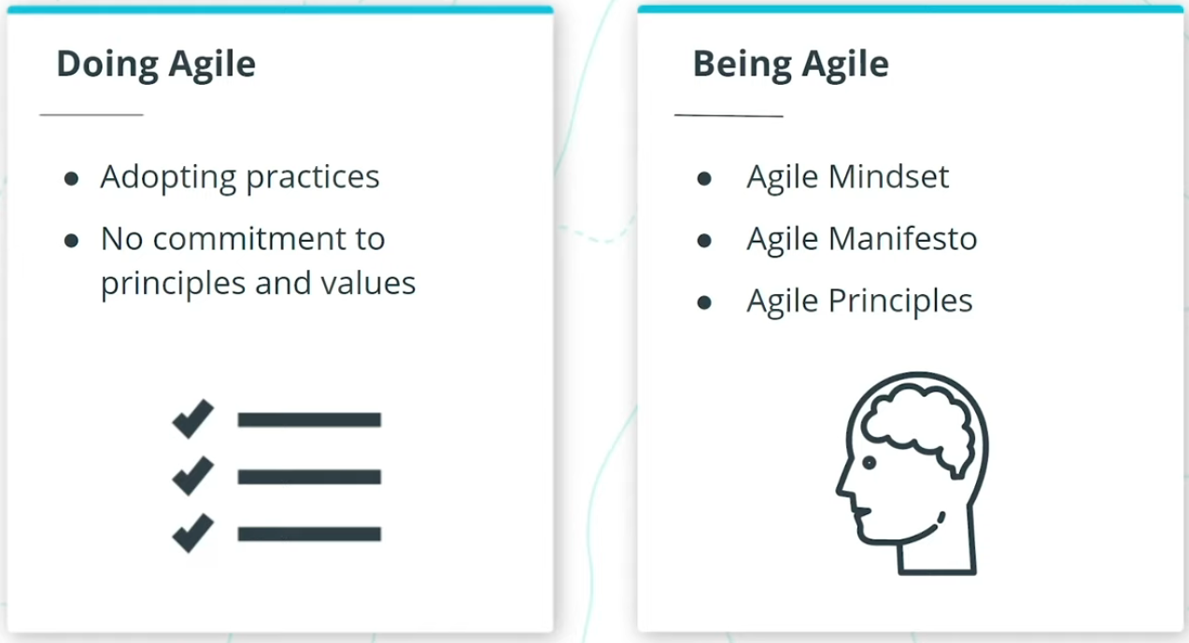

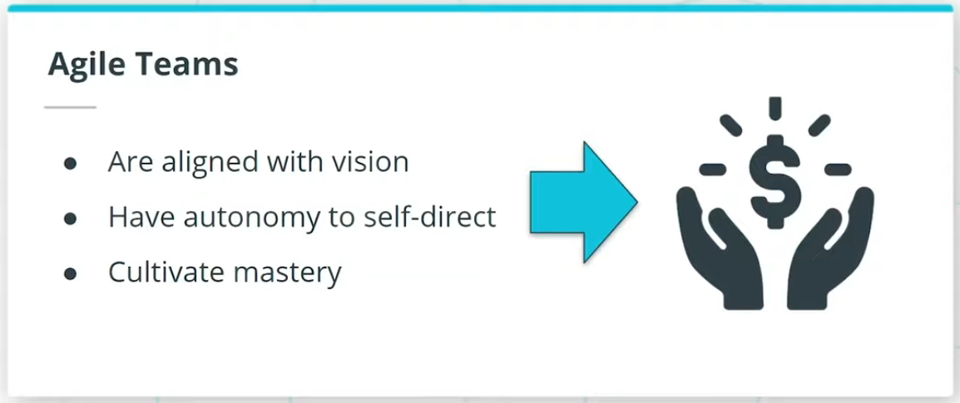

### **Agile permits teams to flourish in an environment that is increasingly Volatile, Uncertain, Complex, and Ambiguous, also known as VUCA.**

* Volatility is when there are unexpected or unstable possibilities that may influence the work being done
* Uncertainty refers to the extent to which an organization can confidently predict or forecast the future
* Complexity exists when there are many interconnected parts and variables that influence each other
* Ambiguity refers to a lack of clarity, such as not having a clear understanding of the genuine needs of the customer and end-users

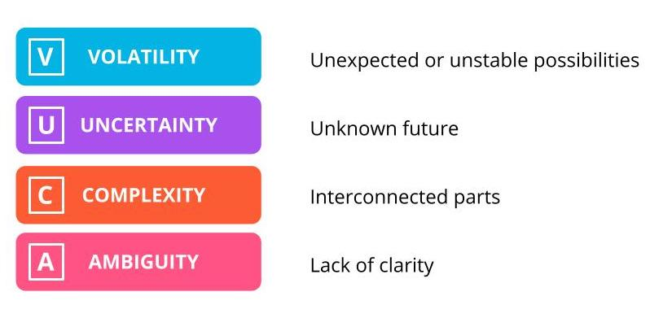

Volatility, Uncertainty, Complexity, Ambiguity (VUCA)

### **Business Agility**

Agile is a set of principles that guide how we as individuals, as teams and as organizations think about, as well as act upon, the work that we do.

Business agility is the ability of an organization to:

* Adapt quickly to market changes
* Respond rapidly and flexibly to customer demands that make business sense
* Adapt and lead change in a productive and cost-effective manner with no compromise to quality

### **The Agile Mindset**

When we talk about an Agile Mindset, we include:

* Respect
* Collaboration
* Continuous Improvement
* Iterative Learning Cycles
* Mastery and Ownership
* Focus on Delivering Value
* Adaptability to Change

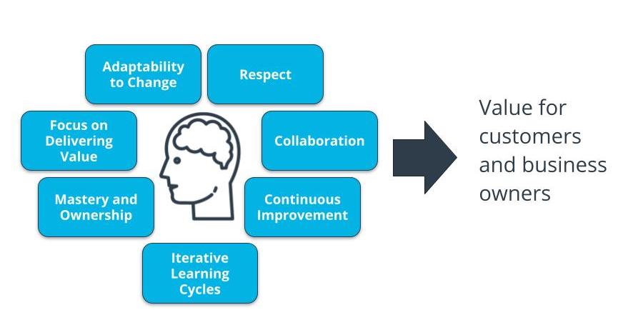

The Agile Mindset

### **Doing Agile vs. Being Agile**

Some organizations and Agile Teams unfortunately just focus on Doing Agile. This equates to simply adopting the practices without committing to or exhibiting agile principles and values.

Being Agile is the foundation that truly elevates individuals, teams, and organizations to unleash their latent potential to deliver monumental and focused value.

### **New Terms**

* **Agile Mindset**: The set of attitudes supporting an agile working environment
* **Being Agile**: When an Agile team lives & breathes Agile principles and values through Agile practices consistently every day
* **Business Agility**: The ability of an organization to adapt quickly to market changes, respond rapidly and flexibly to customer demands that make business sense, as well as adapt and lead change in a productive and cost-effective manner with no compromise to quality
* **Doing Agile**: When an Agile team adopting the practices without committing to or exhibiting Agile principles and values

### **Additional Resources**

* Gil Broza, ***The Agile Mind-Set: Making Agile Processes Work***, 3P Vantage Media, 2015.  
  This book clearly articulates how the missing piece in successfully transforming organizations to Agile is the Agile Mindset.

# Quizzes: The Agile Mindset

## Thinking About the Agile Mindset

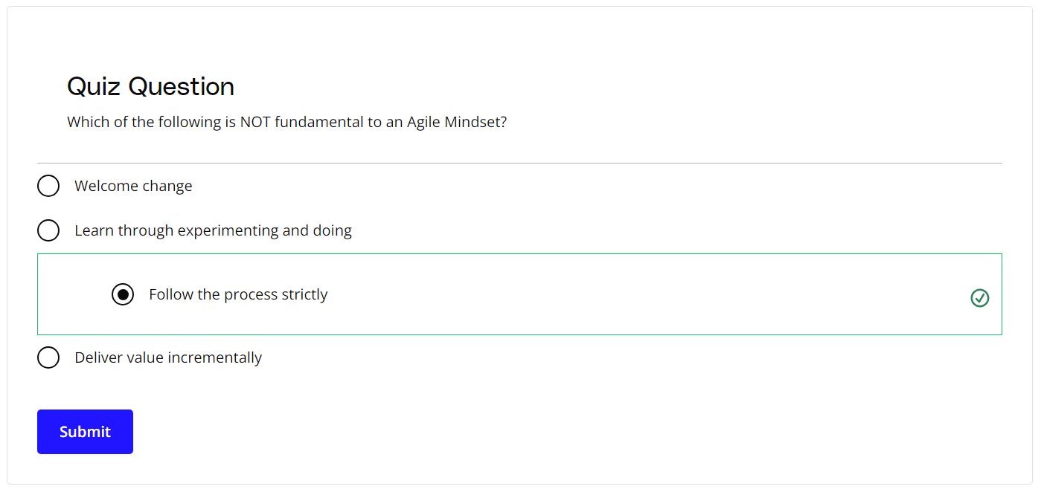

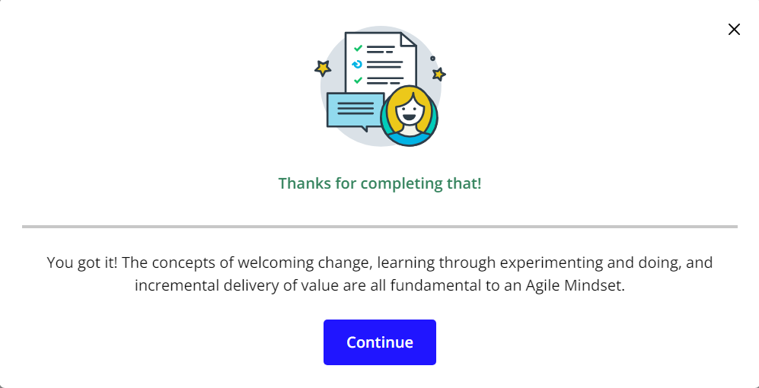

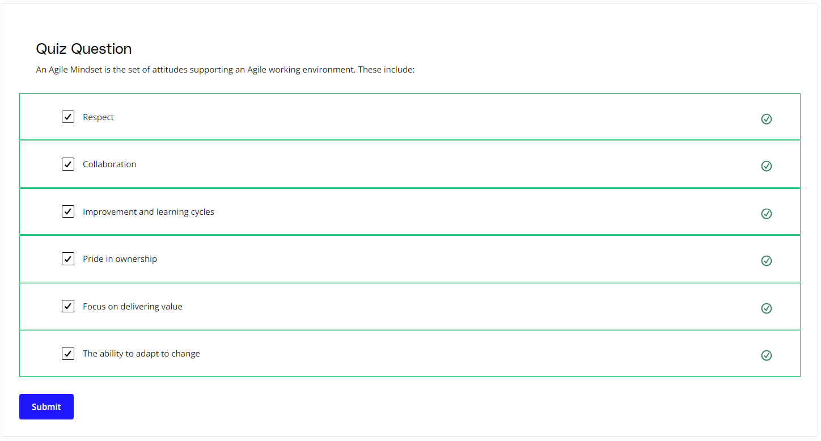

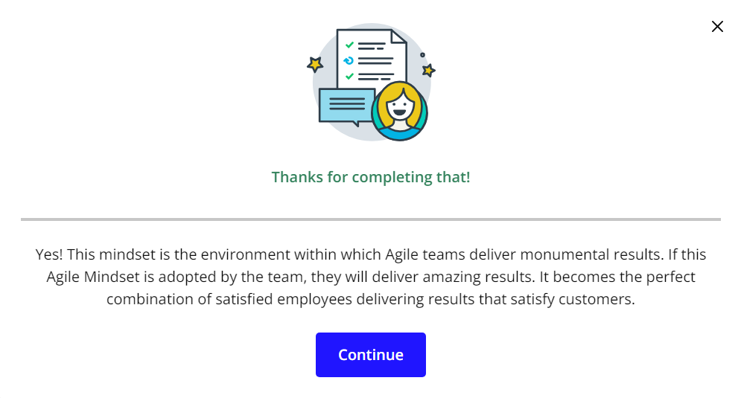

# Exercise: The Agile Mindset

## Applying the Agile Mindset

## Exercise Scenario: SocialKare.gov

SocialKare.gov was launched to allow citizens of Nunamerica to enroll in Social Services provided by the government as a result of a devastating pandemic. Unfortunately, the launch of SocialKare.gov was seen as a disaster from all project management metrics, as well as by its key stakeholders’ low satisfaction ratings. Read what happened in the [**SocialKare.gov Case Study**](https://video.udacity-data.com/topher/2020/September/5f5f6bc7_agnd-c1-foundations-of-agile-socialkare.gov-case-study/agnd-c1-foundations-of-agile-socialkare.gov-case-study.pdf).

You'll also want to download the [**Agile Foundations Course Workbook**](https://video.udacity-data.com/topher/2020/September/5f5f6ba2_agnd-c1-foundations-of-agile-workbook-9-14-20/agnd-c1-foundations-of-agile-workbook-9-14-20.docx). This workbook is in a .docx format, which can be used in most word processing programs including Microsoft Word and Google Docs. To use the workbook in Google Docs, just upload the workbook to your Google Drive and open the document using Google Docs.

***We will be using this scenario and workbook for most of the exercises in this course. We will indicate which worksheet you should fill out for each exercise.***



### **Agile Mindset Anti-Patterns**

Is the SocialKare.gov team operating with an Agile Mindset? Review the Case Study and your notes on the Agile Mindset. What Agile Mindset anti-patterns do you see at SocialKare.gov? Anti-patterns are practices that preventing the Agile mindset from being present and make things worse.

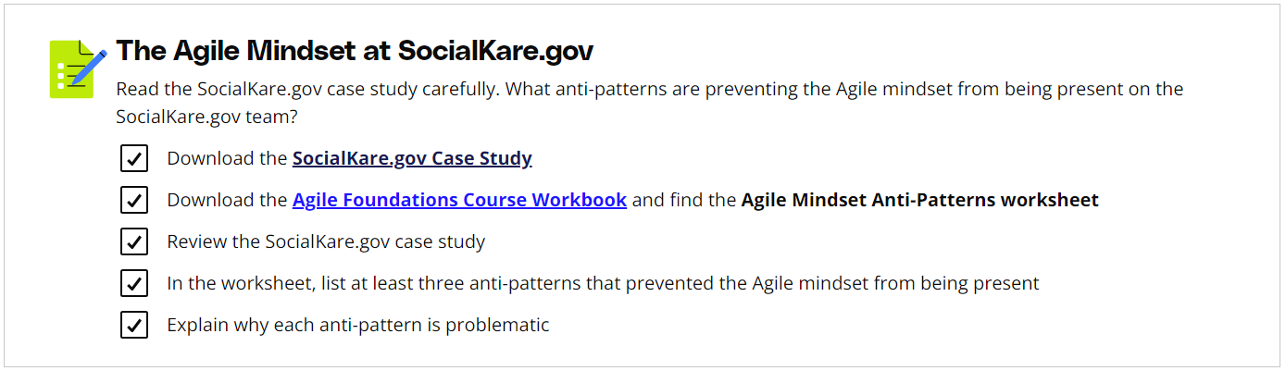

# Solution: The Agile Mindset

## My Solution

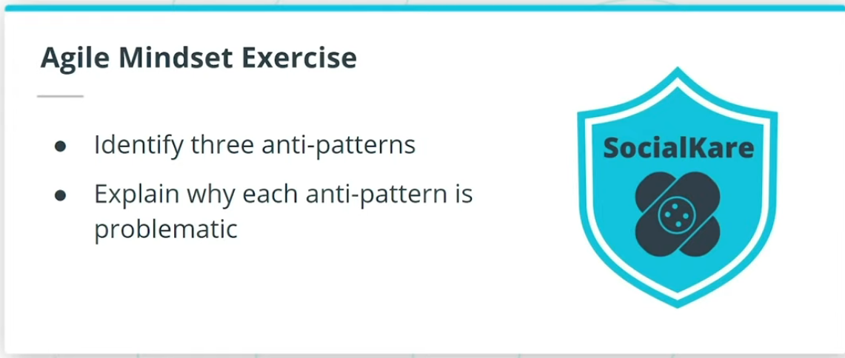

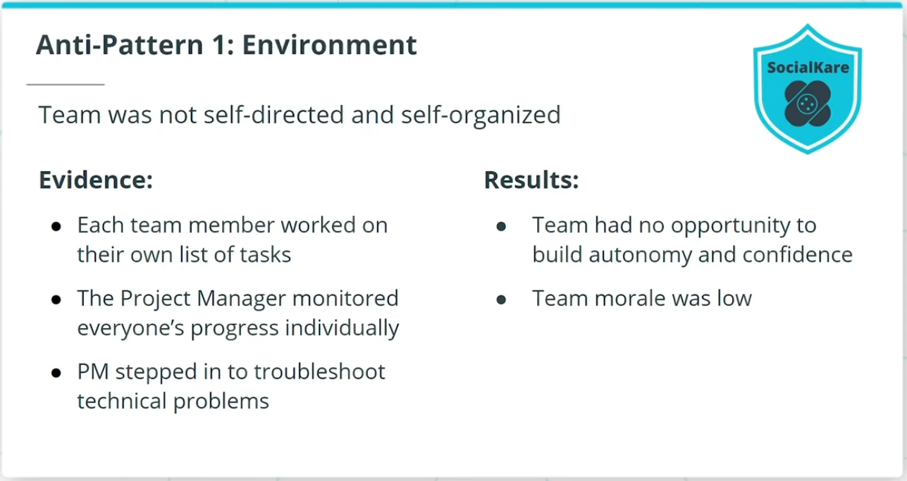

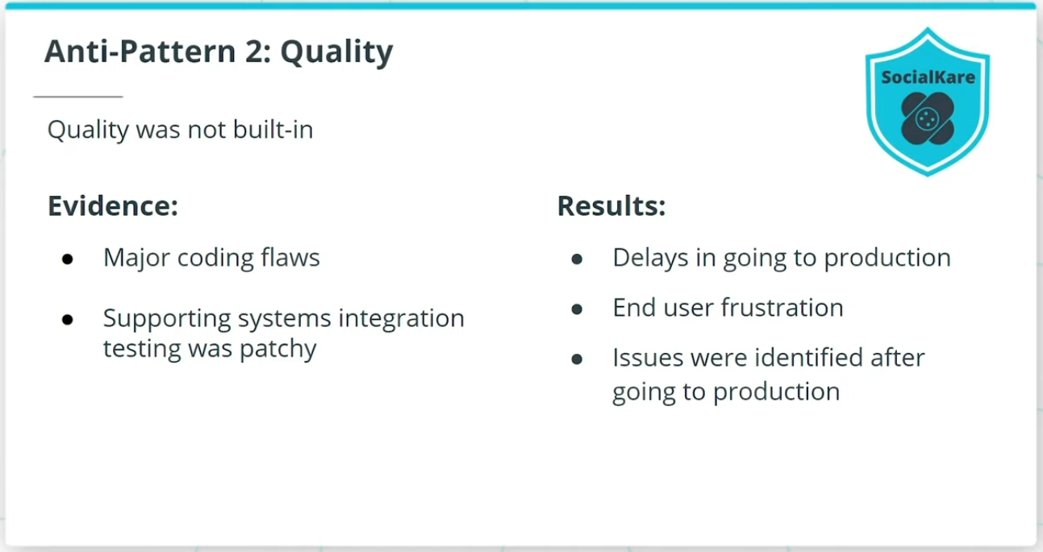

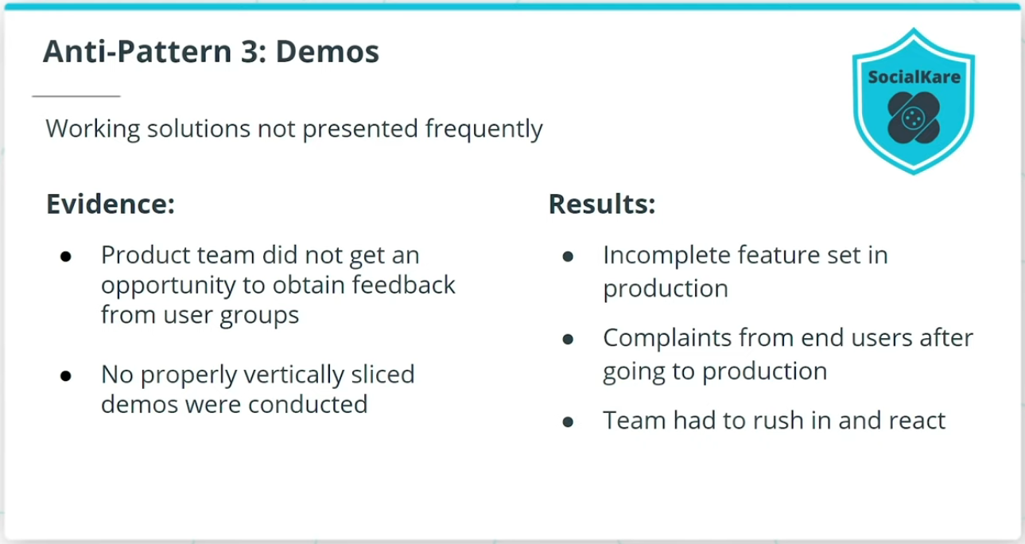

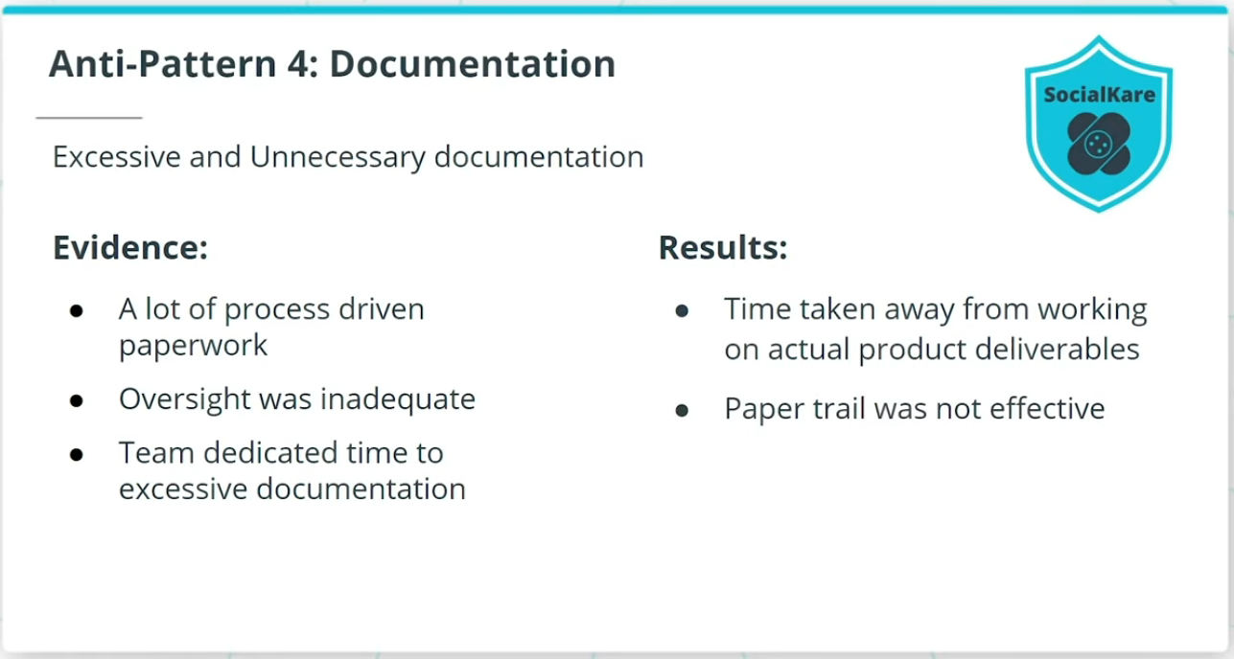

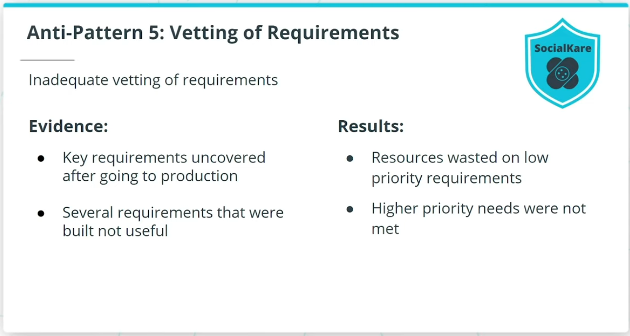

### **The Anti-Patterns I Found:**

* The Project Manager did not build an environment of making the team self-directed and self-organized. As a result, the team did not get an opportunity to build autonomy and confidence without relying on the Project Manager to step in to troubleshoot.
* Quality was not built-in iteratively in the product development life cycle. This resulted in delays in going to production, which frustrated both the business leadership and the end-users.
* Interim working solutions were not presented frequently to the business and end-users for proactive buy-in and feedback. This resulted in an incomplete set of features going to production.
* Excessive and not so valuable documentation was required by the project. As a result, the product results were disappointing.
* There was little in the way of ensuring these requirements made business sense throughout the project life cycle. As a result, the resource effort put into lower priority requirements ended up pushing out the higher priority needs.

